**SET HOSTNAME**

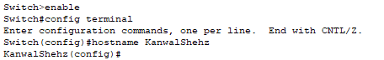

**SET THE LOCAL PASSWORD**

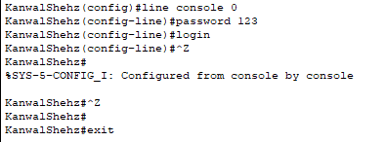

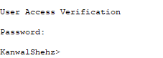

**SET PASSOWRD FOR PRIVILEGE MODE**

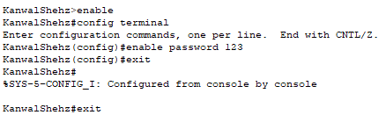



**SET ENCRYPTED PASSOWRD FOR PRIVILEGE MODE**

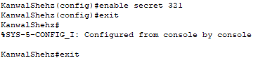



**SHOW RUNNING CONFIG**

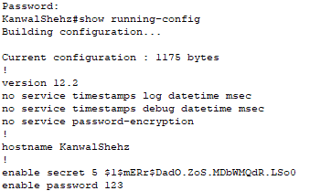

**SET USERNAME AND PASSWORD AND SHOW USERS**

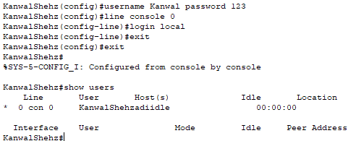

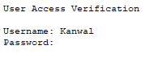

**ENCRYPT PASSWORD OF LOGIN USING SERVICE PASSWORD-ENCRYPTION**

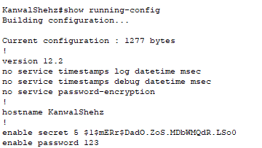

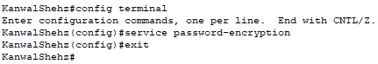

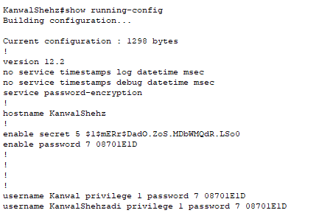

**BANNER**

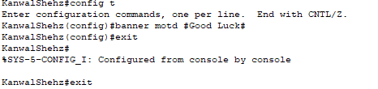



**SHOW CLOCK**

